Ryan Woodward

V00857268

**Part 1: Cognitive Walkthrough**

* Persona: Taylor McGill
* Use Case: File Upload
  + 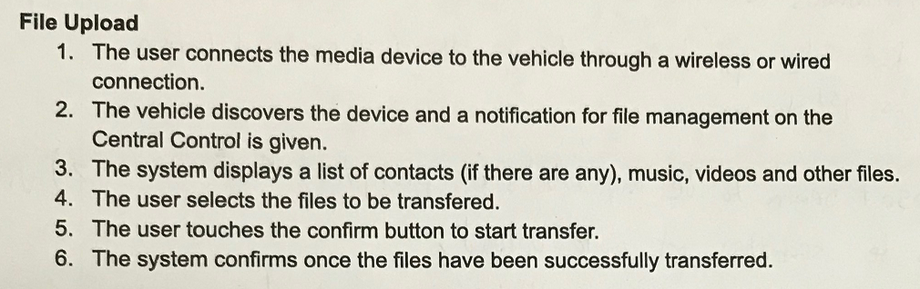
* Prototype Photo:
  + 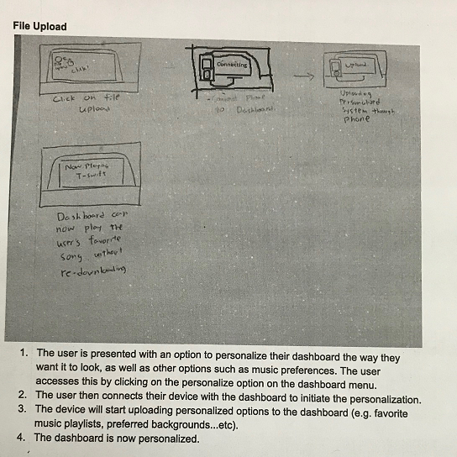
  + In the first step of the use case Taylor wants to be able to connect her media device through a wired or wireless connection. The interface given doesn’t have any visible elements to direct her how to do this. The only button visible on the interface is a single button that states file upload, followed by a notification that the phone is connecting. The single button stating file upload doesn’t give clarification for connecting a phone. There is a feedback screen stating that the phone is currently connecting, but Taylor has no idea how she was able to connect in the first place.
  + The next step of the use case details how the vehicle automatically discovers the device and a notification for file management is given. If Taylor’s intent here is to have her device discovered then the vehicle does all the work on its own and the interface doesn’t provide any visibility to allow her to do this. Although a file upload button does exist, it is the only button on the screen, however this is inadequate feedback for Taylor to know whether or not her phone has connected. At this point all she sees in front of her is a file upload button.
  + From here the interface now determines the phone to be connecting to the vehicle after the file upload button has been pushed which is a complete contradiction of the use case. The use case details the fact that the vehicle will connect to the phone and then a file management system will be displayed, whereas the prototype determines that the file upload button exists first, and then after that is pushed the media device will connect to the vehicle.
  + The use case now outlines that a list of contacts, music, video, and other files will automatically be displayed to Taylor. The prototype however doesn’t offer any visible feedback that these will be displayed. There are no buttons for her to select which of her personalized options she wishes to actually be transferred. When analyzing the prototype it is assumed that the vehicle automatically uploads all of the personalization from the media device itself without the user having any control of what gets uploaded.
  + Taylor now wishes to select which files she would like to be transferred. However she has no idea how to do this since there are no visible symbols or icons for her to be able to select. There is no feedback to speak of to be offered as it is assumed that the vehicle does all of the work.
  + Taylor now wishes to push the confirm button to begin the transfer. There is no visible icon labelled confirm to allow her to do this. The interface given simply assumes that the dashboard will upload all of the personalization options automatically. There is no feedback given since she is unable to push a button in the first place.
  + The system does confirm that the files have been transferred as feedback, but Taylor has no idea what has happened at this point. All she has been able to do is connect her phone to the dashboard, pushed one file upload button, and everything happened in the background without her being able to control anything.
* Persona: Bob Lee
* Use Case: Navigation
  + 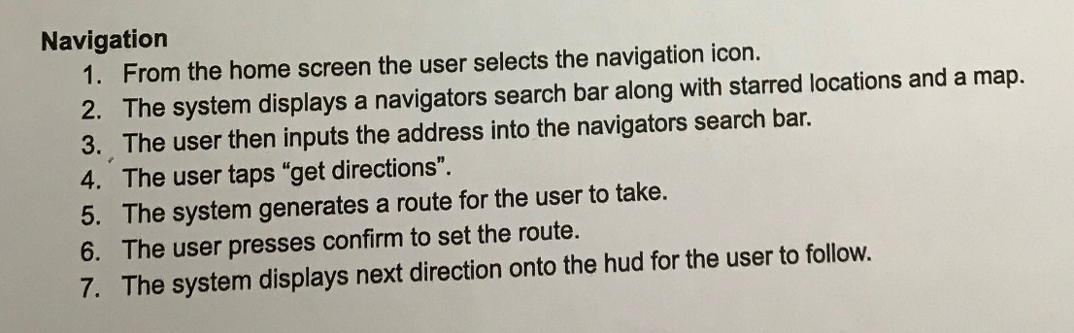
* Prototype Photos:
  + 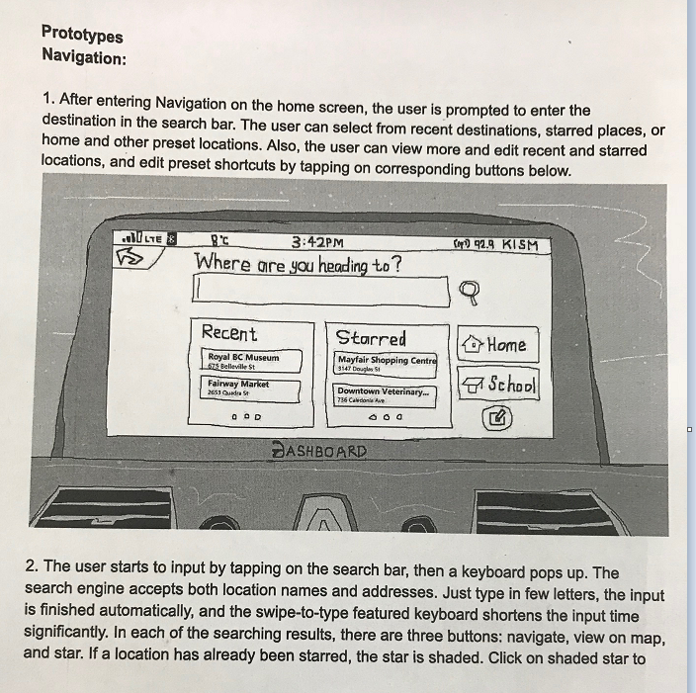
  + 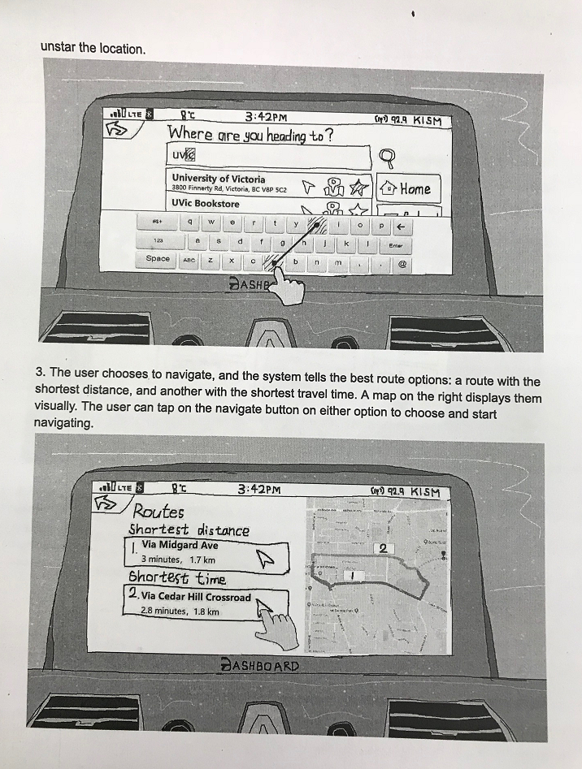
  + 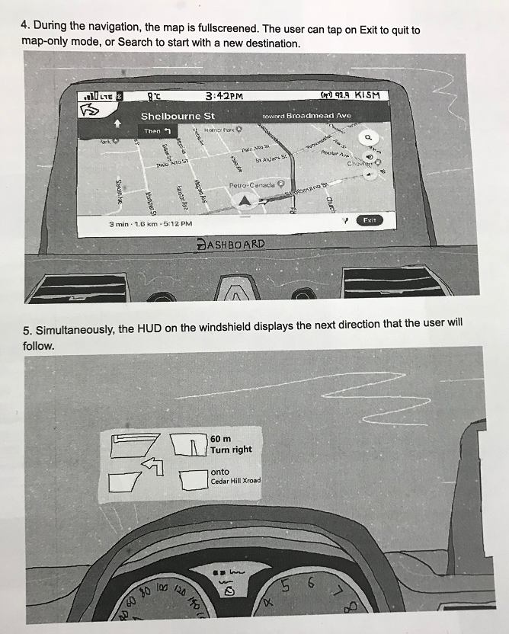
* **Cognitive Walkthrough**
  + When starting the use case Bob wants to input some navigation. The search tool is large and hard to miss.
  + The keyboard pops up and uses a swipe to type feature that will auto complete the search for Bob. There is no real signifier for this, it is expected that bob will discover how to do this on his own.
  + The map options when they pop up are clear. It’s easy for Bob to see which route he wants to take, and the symbols are easy to follow in terms of starring the options.

**Part 2:**

* I would make significant changes as the use cases were not personalized to the personas that were offered. In both cases the use cases were simply a vague list of “the user” performing a set of instructions. It would have been much better to do these use cases as if it was from the perspective of the personas. Also the use cases did not match up with the prototypes presented.
* The file upload prototype seemed significantly incomplete. It was quite difficult to analyze as the first picture simply had a single button on it that stated file upload. The direction of the prototype did not match up with the use case, it really felt like multiple people were tasked with each section and just threw it together with zero collaboration. The prototype seemed to be based on the design that the vehicle simply connects with your phone and does everything in the background. This doesn’t seem like much of an interface as with this concept there is nothing to push or choose what to do.